**Experiment No. 1.1**

**Student Name:** Gaurav Kumar **UID:** 22MCC20177

**Branch:** MCA**–**CCD **Section/Group:** MCD-1/A

**Semester:** IV **Date of Performance:** 18th Jan 24

**Subject Name:** Continuous Integration **Subject Code:** 22CAP-745

/ Continuous Delivery

1. **Aim/Overview of the practical:**
   1. Install and setup git in your Systems.
   2. Create a python file named as your UID (eg.22MCC20001.py) with some code inside it on a Local Repository named as your UID (e.g. 22MCC20001). Push this file on Remote Repo.
   3. Create another Local Repository named as your name (e.g. ABC) and pull the files from Remote Repo in it. After this, create a new file in new Local Repo i.e. ABC and push it to Remote Repo. Again, pull the files on old Local Repo i.e. 22MCC20001.
   4. At last, visit Remote Repo and commit some changes in a file created i.e. 22MCC20001.py and pull the file again in new Local Repo i.e. ABC. Check whether the changes are existing in file in Local Repo or not.
2. **Code for practical: (a)**
3. To install ***Git,*** you can use winget package manager on windows.

e.g, ***winget install -e --id Git.Git***

1. After successful installation configure **Git** using **git config** command.

e.g, ***git config --global user.name "Your Name"*** and

***git config --global user.email “you@example.com”***

**Code for practical: (b)**

1. Open **terminal** and create a folder with your name with the help of ***mkdir*** command.
2. Change directory to above created folder using ***cd 22MCC20177***.
3. Create a new ***22MCC20177.py*** file.

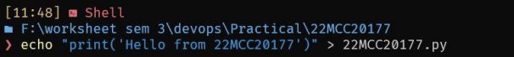

1. Initialize git using ***git init***.
2. Now create a new main branch using ***git branch -M main.***
3. After that add file to staging arear of git using ***git add 22MCC20177.py***
4. Commit changes using ***git commit -m “Message”***.
5. After that open Github.com and create new remote ***GitHub repository.***
6. After that link your remote and local repository together using ***git remote add origin <remote_repository_link>.***

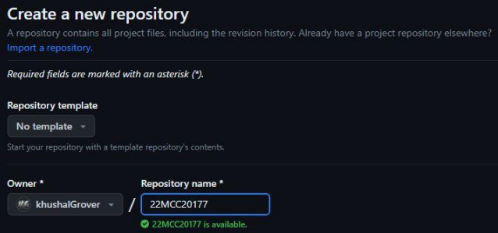

1. Now push local repository to remote repository using ***git push -u origin main.***

**Code for practical: (c)**

1. Create another folder named **Gaurav Kumar** using ***mkdir*** command.
2. To pull from GitHub repository initialize empty git repository using ***git init*** command.
3. After that link remote repository to the local repository using ***git remote add origin <remote_repository_link>.***



1. Now you can pull from remote repository using ***git pull origin main.***



1. Now create a new file and add it on git staging area using ***git add <filename>*** command.
2. Commit changes using ***git commit -m “Message”***.
3. To push new changes to remote repository, use git using ***git push -u origin main.***
4. To pull the new changes to the old local repository use ***git pull origin main*** command.

**Code for practical: (d)**

1. Goto remote repository on GitHub and create new file and commit the changes.
2. To pull the changes made on remote repository to the local repository use ***git pull origin main.***

1. The above command will fetch all the new updates to local repository and to verify if the file is present on the local repository or not you can use ***ls command*** to list all the content of current folder and verify if file is there or not.